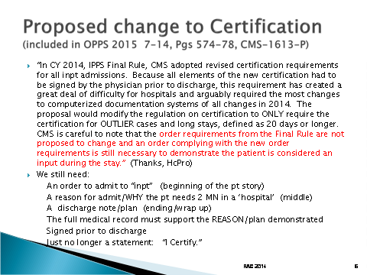

**Take Aways:**

I still see the need for a consistent message

* We do need an order – any payer
* We do need to ensure the reason for admit/plan for the inpt level of care is clearly outlined from the beginning – for any payer
* We do need to have the expectation of 2 MN to resolve the pt’s condition – still clear – Medicare only
* We do need a discharge plan/note ----all elements signed prior to discharge – optional for all payers, but consistency with IT help, great!

So what may be changing? I am still a strong proponent of having a PROCESS that works every time… key elements and if a ‘form’ or internal queing system gives our providers what they need every time – still use the form or something similar. HARD STOPS are the key…

I didn’t see any change address ‘Attending’ must sign all prior to discharge. It may come if we have a ‘final’ change so stay tuned…but hard stop now to ‘catch’ any that didn’t get co-signed.

So we may not, if implemented , have to have a ‘certification statement – “I Certify…” But a consistent process that lays out all the elements every time --- I can’t think of a better way to start and end a strong patient story. Ques and hard stops helps …